Final Project Research Question  
Student: Duncan Ferguson

Research Question

* Has the U.S. started to Export more LNG to NATO?
* What Percentage of our LNG export are being directed to Nato?
* What percentage of Europe’s Natural demands need to be met by LNG/Imports?
* How much of European Natural Gas is met by sources that are not Russia?
* Can we forecast Europe’s Natural Gas Demands? And how they are going to be met in the future?

**Data Sources**

# US LNG EXPORTS BY Country  
<https://www.eia.gov/dnav/ng/NG_MOVE_EXPC_S1_M.htm>

# EU Data for Imports of Natural Gas by Partner Country  
<https://ec.europa.eu/eurostat/web/energy/data/database>

<https://ec.europa.eu/eurostat/databrowser/view/nrg_ti_gasm/default/table?lang=en>

# European Supply, Transofrmation and consumption of gas  
<https://ec.europa.eu/eurostat/databrowser/view/nrg_cb_gasm/default/table?lang=en>

Screen shot of U.S. Natural Gas Exports that needs to be scraped.

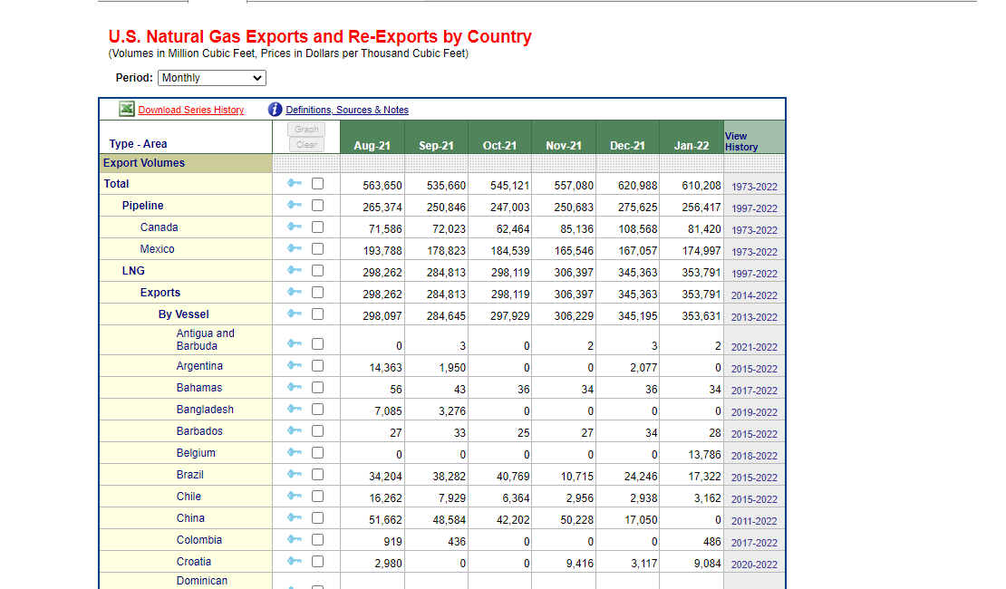

Screen Shot of Europe Natural Gas Imports That needs to be scraped

